**Technical Design Document**

**Name:** Richard Kudrya

**Date Created: 09/02/2025**

**Program Description:**

This program lists four products to where discounts are applied. The program will display the name of the product, its original price, its discount amount and final price. The original program had an error in which I had to de-bug.

**Functions used in the Program (list in order as they are called):**

1. **Function Name:** calculate_discount(price, discount_rate):

**Description:** This function calculates the discount amount towards the product with the corresponding discount rates.

**Parameters:**

* price : The original price of product
* discount_rate : The discounted rate of the product
* product_name : The name of the product

**Variables:**

* price_f : float, price value of product
* rate_f : float, discount rate for product
* discount_amount : float, discount rate in dollars

**Logical Steps:**

1. Make price and discount_rate floats
2. Validating the price is not negative
3. Converting whole numbers to percentages while making sure theyre between 0 and 1
4. Calculate the discount

**Returns:**

discount_amount : the final discounted price of the product.

2. **Function Name:** apply_discount(price, discount_amount):

**Description:** Calculates the final price of the product by applying the discount

**Parameters:**

* price : The original price of product
* discount_amount : The amount to take off from original price
* product_name : Name of product

**Variables:**

* price_f : float, price value of product
* discount_f : float, Discount value of product
* final_price : float, final price value of product after discount

**Logical Steps:**

1. Make inputs into floats
2. Make sure the discount is not negative
3. Subtract the discount price from original
4. Make sure final price isn’t negative

**Returns:**

Final_price : float, final price rounded after applied discount

3. **Function Name:** main()

**Description:** Calculates the discount amount for a product, applies it, and displays the final price.

**Variables:**

* products
* name, price, discount_rate, discount_amount

**Logical Steps:**

1. Define the product list
2. Call out calculate_discount() and apply_discount() to each of the products

**Logical Steps:**

1. List the order in which your functions are called.
2. main()
3. calculate_discount()
4. apply_discount()
5. print()

**Link to your repository:** <https://github.com/Roboriko/PythonCOP2373>

**Output Screenshot: (make sure big enough so I can see)**

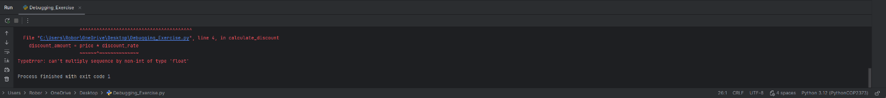

**De-Bugging Process:**

1. **Original program came with a TypeError: can’t multiply sequence by non-int of type ‘float’**
2. **I used the de-bugger in PyCharm**
3. **Noticed the Tablet’s price of 500 was written as a string “500” instead of a number so I turned the string into a numerical value**
4. **I then modified the code error handling by converting inputs into numbers, making sure the program checks for negative prices and invalid discount rates, as well as letting the program accept percentages and decimals**